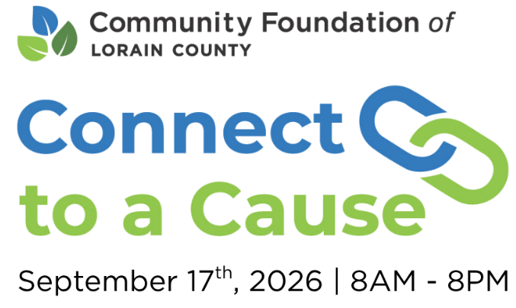

C2C Supporter Letter or Email
Subject: Join [Non-Profit Organization] for Connect to a Cause

Hello [Supporter],
Thanks to your generosity, [Non-Profit Organization] continues to grow and serve our Lorain County community in meaningful ways. We are deeply grateful for your support and are thrilled to share another opportunity to continue our partnership.
This year, we’re participating in Connect to a Cause, a 12-hour crowdfunding campaign hosted by the Community Foundation of Lorain County that helps nonprofits like ours sustain vital community work. We would be honored to have your support once again!
On September 17, from 8:00 a.m. to 8:00 p.m., you can support our cause by donating through Connect to a Cause. Whether by cash, check, or online, every gift counts and helps us earn bonus dollars to stretch your impact even further. You can make your online gift during Connect to a Cause at peoplewhocare.org. It’s a powerful way to show your support for our mission and make a real difference in our community.
Use the hashtag #C2CLorainCounty on social media to connect with other non-profit participants. Together, we can spread the word and inspire even more people to get involved.
Mark your calendars and join us on September 17. Together, we can achieve much!

Best,
[Your Name]
[Non-Profit Organization]

C2C Supporter Letter or Email
Subject: Help Us Make a Difference on September 17

Hello [Supporter],
We have been reflecting on how far we’ve come, and how much of that is because of you. Your support of [Non-Profit Organization] makes a real difference, and we do not take that for granted. We hope you will continue your steadfast support for another exciting event.
Our organization is participating in Connect to a Cause, a 12-hour crowdfunding campaign hosted by the Community Foundation of Lorain County. On September 17, from 8:00 a.m. to 8:00 p.m., we will raise funds to help us achieve our mission to [insert your mission here].
Every contribution matters. Whether you choose to give online at peoplewhocare.org, or prefer to donate by cash, check, or another method, your support helps us move our mission forward.
To make the day even more meaningful, we invite you to connect with us online and help spread the word using #C2CLorainCounty. Follow us on [insert your social media channels], where you can stay updated on our work, share your support, and engage with others who care about our cause.
We hope you’ll join us on September 17 and help us raise the funds we need to keep moving forward. Your gift that day could unlock bonus dollars and extend our impact even further. Thank you again for standing with us. We are grateful to have you in our corner!
Best,
[Your Name]
[Non-Profit Organization]

