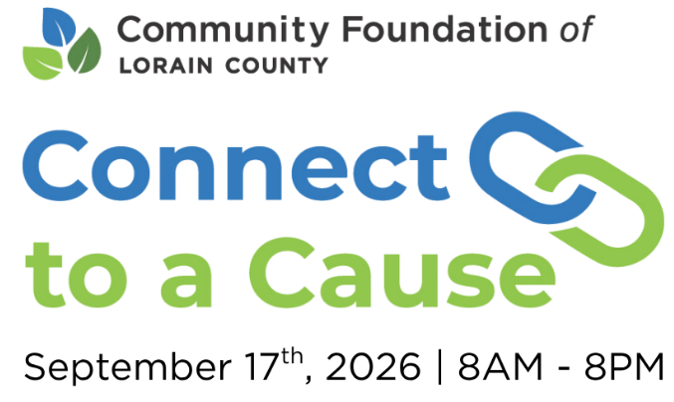
C2C Donor Letter or Email
Subject: Join [Non-Profit Organization] for Connect to a Cause
Dear [Donor Name],
We’re continually grateful for your support; it’s what allows [Non-Profit Organization] to keep showing up for our community, day after day. Your generosity makes a real difference, and we’re excited to share an upcoming opportunity where that impact can go even further.
On September 17, from 8:00 a.m. to 8:00 p.m., we’ll take part in Connect to a Cause, a 12-hour crowdfunding event hosted by the Community Foundation of Lorain County. This event helps [Non-Profit Organization] grow our endowment, support vital programming, and deepen our impact across Lorain County.
This year, we’ve set a goal to raise [$amount] to support our ongoing work. And thanks to bonus opportunities throughout the day, your generosity can go even further, helping us expand our reach and deepen our impact.
Whether you choose to donate by cash, check, or online during the event, we truly appreciate your support. Online gifts can be made quickly and securely at peoplewhocare.org during Connect to a Cause. The Community Foundation of Lorain County can also help facilitate non-cash contributions, including gifts of stock, donor-advised funds, or qualified charitable distributions. These giving options can support our mission while offering potential tax advantages to you.
Every dollar raised will go directly toward our ongoing initiatives and growing our endowment, ensuring we can continue serving our community effectively. Consider reaching out to friends, family, and colleagues who share your love of giving. Your personal encouragement can go a long way in inspiring support on this exciting day. You can also help amplify the impact by using the hashtag #C2CLorainCounty on social media to connect with others in our community.
We’re humbled by your continued support. Thank you for standing with [Non-Profit Organization]. We’re proud of what we’ve accomplished together, and excited for what is ahead!
With warm regards,
[Your Name]
[Non-Profit Organization]

