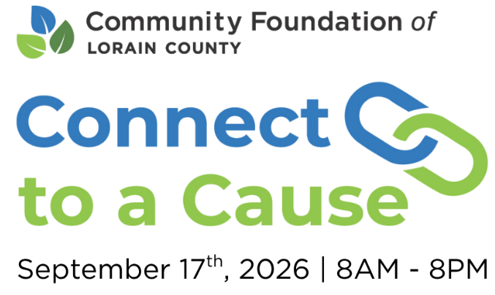

Board Member Template 1
Subject: Mark your calendar: Support [Non-Profit Name] on September 17

Dear [Board Member],
Thanks to your generous support, [Non-Profit Organization] continues to grow and serve our community in powerful ways. This year, we are proud to join the Community Foundation of Lorain County for Connect to a Cause, a 12-hour crowdfunding campaign that helps non-profits like ours connect with new supporters, unlock matching funds, and deepen our impact right here at home. Since its launch in 2020, Connect to a Cause has raised over $1M for participating non-profits. This year, with your help, we can go far.
On September 17, from 8:00 a.m. to 8:00 p.m., donors can visit the online Connect to a Cause catalog at peoplewhocare.org and choose from over 100 local non-profits, including ours, to support. Every dollar raised for [Non-Profit Organization] during this event will power our annual programs and endowment. Donations made by cash, check, or online during the event will also activate additional bonus dollars based on the total amount raised throughout the day.
Many generous Connect to a Cause supporters have chosen “tax-smart” ways to give, such as contributing stock, making grants from donor-advised funds, or making Qualified Charitable Distributions. These strategies provide great benefits, so that you can both give and gain during Connect to a Cause.
No matter how you give, your donation is a powerful expression of our shared commitment to a thriving, supportive Lorain County community.
Please mark your calendar for September 17 and visit peoplewhocare.org to learn more. Share Connect to a Cause with your network, and you will help us attract new donors and raise even more funds to support our mission. A personal message from you can encourage others to support our organization on this exciting day.
Thank you again for standing with us. We sincerely appreciate your continued dedication to our organization and look forward to seeing what we can achieve together.
Let's make this year's Connect to a Cause our best yet!
Sincerely,
[Executive Director]
Board Member Template 2
Subject: Thank you for your support- here’s how to help again on September 17

Dear [Board Member],
You are a valued supporter of [Non-Profit Organization], and we sincerely thank you for your steadfast commitment to our mission. Your generosity has made a profound difference in our ability to serve the community and advance our goals.
This year, we are thrilled to join Connect to a Cause, a 12-hour crowdfunding campaign hosted by the Community Foundation of Lorain County. This powerful initiative helps non-profits like ours connect with new supporters, deepen our impact, and grow our endowment. Since its inception in 2020, Connect to a Cause has raised over $1M for participating non-profits!
We want to surpass our past success, and you can help make this happen. Donate to [Non-Profit Organization] during Connect to a Cause on September 17 from 8:00 a.m. to 8:00 p.m., and your gift will directly support our vital community work. Even better, your donation will help us receive bonus dollars based on the total amount raised throughout the day. Online gifts can be made quickly and securely at peoplewhocare.org during Connect to a Cause.
We are proud of what we have accomplished at [Non-Profit Organization], but none of it would be possible without generous supporters like you. Join us during Connect to a Cause by making a gift and helping us grow. You can also amplify the day's impact by using the hashtag #C2CLorainCounty on social media to connect with others in our community.
Thank you once again for your continued support. Together, we can make a meaningful difference for the people who count on us.
Sincerely,
[Executive Director]

